GULF INDUSTRIAL SERVICES CO. Life Savings Rules [LSR] requirements are developed to ensure that all employees will commit themselves to adhere with safety precautions among all our core activities within the company.
All GIS employees are expected to fully support and cooperate in the implementation of these 10 Life Saving Rules – I CARE FOR 10.
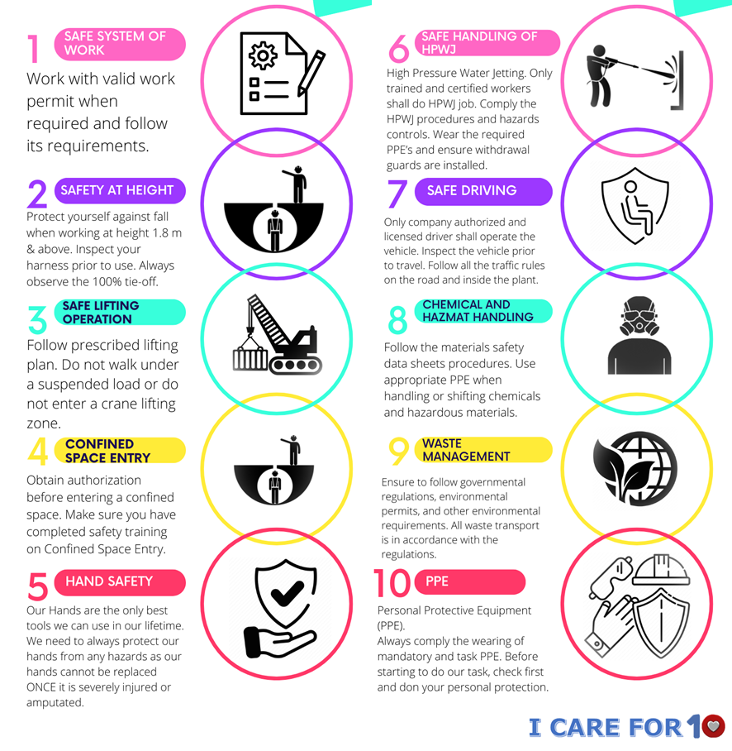

DENNIS M. S. JOSE PG SABU
HSE & LP Manager General Manager

